Election Commission Meeting – June 28, 2024
PUBLIC NOTICE
Gladwin County
Please take notice that there will be a meeting of the Election Commission on Monday, July 2, 2024, at 9:00 a.m. at the office of the County Clerk. The purpose of this meeting is to approve Early Voting Election Inspectors for the August Primary Election and to perform preliminary accuracy testing.

Karrie Hulme,
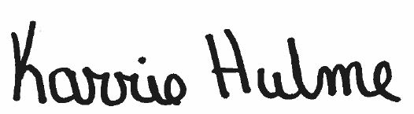
Gladwin County Clerk

Posted 06/11/2024

